**Assignment 1**

Create the following tables with the given structures and insert sample data as specified: -

A) mysql> create table SALESPEOPLE(

-> Snum INT(4),

-> Sname Varchar(10),

-> city Varchar(10),

-> comm float(3,2)

-> );

insert into SALESPEOPLE(Snum, Sname,City, Comm)values

-> (1001, 'peel','london' , 0.12),

-> (1002, 'serres','San jose' , 0.13),

-> (1004, 'Motika','london' , 0.11),

-> (1007, 'Rifkin','Barcelona' , 0.15),

-> (1003, 'Axelrod','New York' , 0.10);

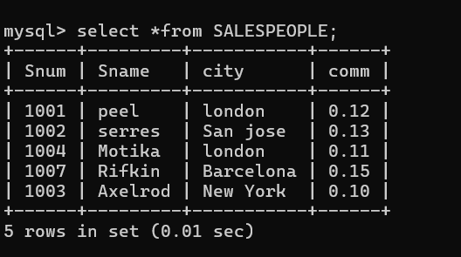

B) mysql> create table customers(

-> Cnum int(4),

-> Cname varchar (10),

-> City varchar (10),

-> Rating int(4),

-> Snum int(4)

-> );

Query OK, 0 rows affected, 3 warnings (0.06 sec)

mysql> insert into customers(Cnum , Cname, City, Rating, Snum)values

-> (2001, 'hoffman', 'london', 100, 1001),

-> (2002, 'Giovani', 'rome', 200, 1003),

-> (2003, 'Liu', 'San Jose', 200, 1002),

-> (2004, 'Grass', 'Berlin', 300, 1002),

-> (2006, 'Clemens', 'London', 100, 1001),

-> (2008, 'Cisneros', 'San Jose', 300, 1007),

-> (2007, 'Pereira', 'Rome', 100, 1004);

Query OK, 7 rows affected (0.01 sec)

Records: 7 Duplicates: 0 Warnings: 0

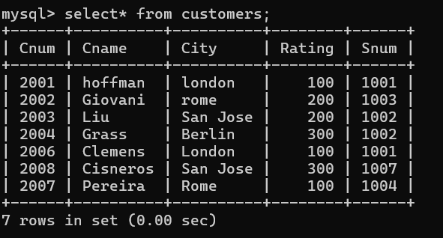

C) mysql> create table Orders(

-> Onum INT (4),

-> Amt float(7,2),

-> Odate Date,

-> Cnum INT(4),

-> Snum INT(4)

-> );

mysql> insert into orders(Onum, Amt, Odate, Cnum, Snum)values

-> (3001, 18.69, '1990-10-03' , 2008, 1007),

-> (3003, 767.19, '1990-10-03', 2001, 1001),

-> (3002, 1900.10, '1990-10-03', 2007, 1004),

-> (3005, 5160.45, '1990-10-03', 2003, 1002),

-> (3006, 1098.16, '1990-10-03', 2008, 1007),

-> (3009, 1713.23, '1990-10-04', 2002, 1003),

-> (3007, 75.75, '1990-10-04', 2004, 1002),

-> (3008, 4723.00, '1990-10-05', 2006, 1001),

-> (3010, 1309.95, '1990-10-06', 2004, 1002),

-> (3011, 9891.88, '1990-10-06', 2006, 1001);

Query OK, 10 rows affected (0.02 sec)

